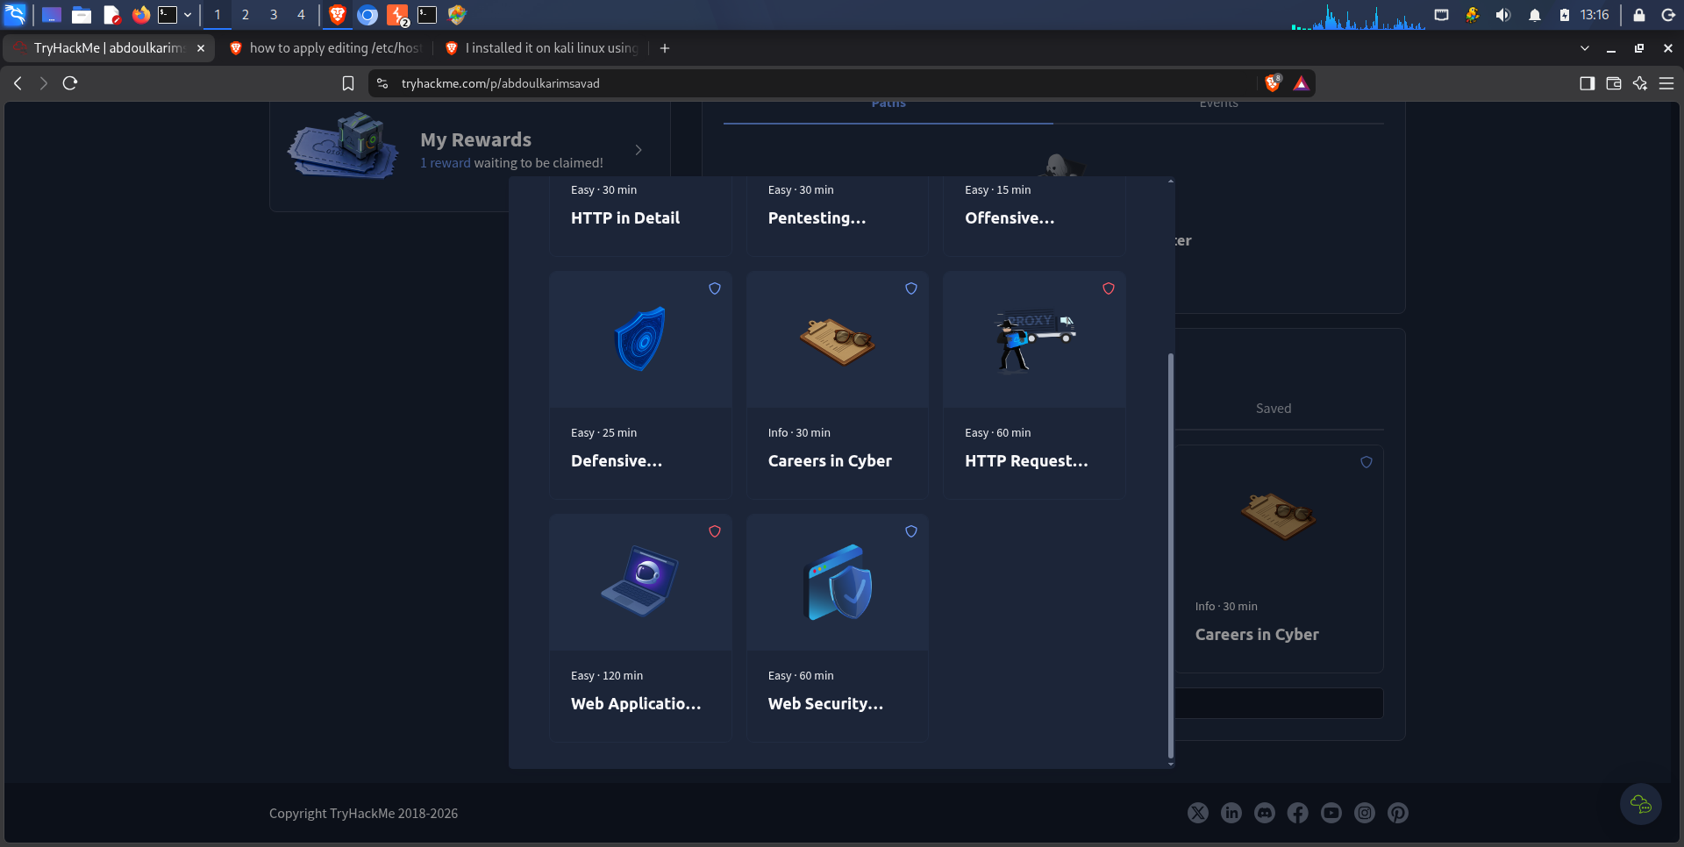

Summary of Key Takeaways
Lab 1: HTTP in Detail
In the first lab, I gained a deeper understanding of HTTP and HTTPS, including how HTTP requests and responses work. I learned about the different HTTP methods and their purposes, as well as HTTP status codes and how they communicate the outcome of a request to the client. I also explored HTTP headers and how they provide additional information about requests and responses. Finally, I learned how cookies are used to store data on the client side and how they help maintain state, including user sessions, across multiple requests.
Lab 2: HTTP Request Smuggling
In the second lab, I learned what HTTP Request Smuggling is, how it works, and how attackers can exploit discrepancies in the way HTTP requests are interpreted by different servers or intermediaries. I explored the three main types of request smuggling: CL.TE, TE.CL, and TE.TE. I also worked through a practical example to better understand how this vulnerability can be exploited and why proper HTTP request parsing and validation are essential for web application security.

